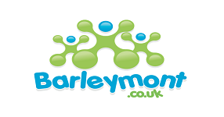
PAUK LTD - Barleymont Group
Day Nursery, Pre-School & After-School

UNIFORM POLICY AUDIT TOOLS
 | Room/Setting: | Staff Checked
 | Auditor: | 1 | 2 | 3 | 4 | 5 | 6 | 7 | 8 | 9 | 10
 | Date:
1 | The member of staff is using appropriate PPE
2 | No wrist watches are being worn when carrying toilet/nappy care
3 | Long hair is tied up
4 | Hair is clean, neat and tidy
5 | Rings- one plain ring only is being worn if at all
6 | Shoes are low heeled/flat closed at the toe and heel
7 | Shoes are black
8 | Foot wear is of a material that can be wiped
9 | Plain dark socks are worn with trousers (if worn)
10 | Earrings- one plain pair of stud earrings or no earrings
11 | Tights/stockings are plain natural or dark in colour
12 | Name badge is clean and sticker free
13 | Cardigans are not being worn during patient care
14 | All badges are professional
 | Score
 | Possible Score

*Please return a copy of this audit to the HR Manager*
Each Room/Setting must complete this tool every 6 months
Scores will be fed back to relevant managers, and form part of the infection prevention and control annual report.

